**EXAM NO:220340325035**

Q1. Create a sample table in postgres/mysql with following columns (15 Marks)Table Name : cdac_power_bi  
Column  
Name - varchar  
Id- integer  
Age- integer  
Dob - date  
Insert 5 dummy rows into it and then connect to superset and populate  
1. Table Chart  
2. Card chart showing max age

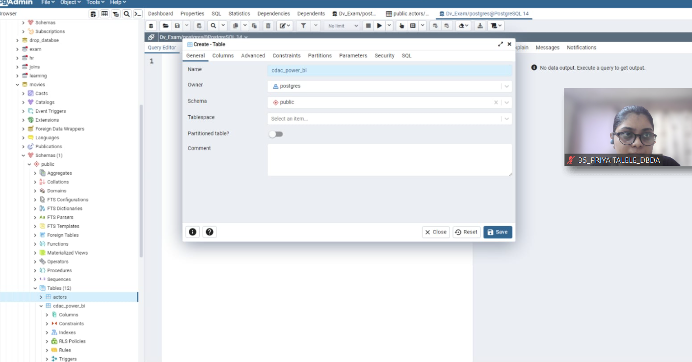

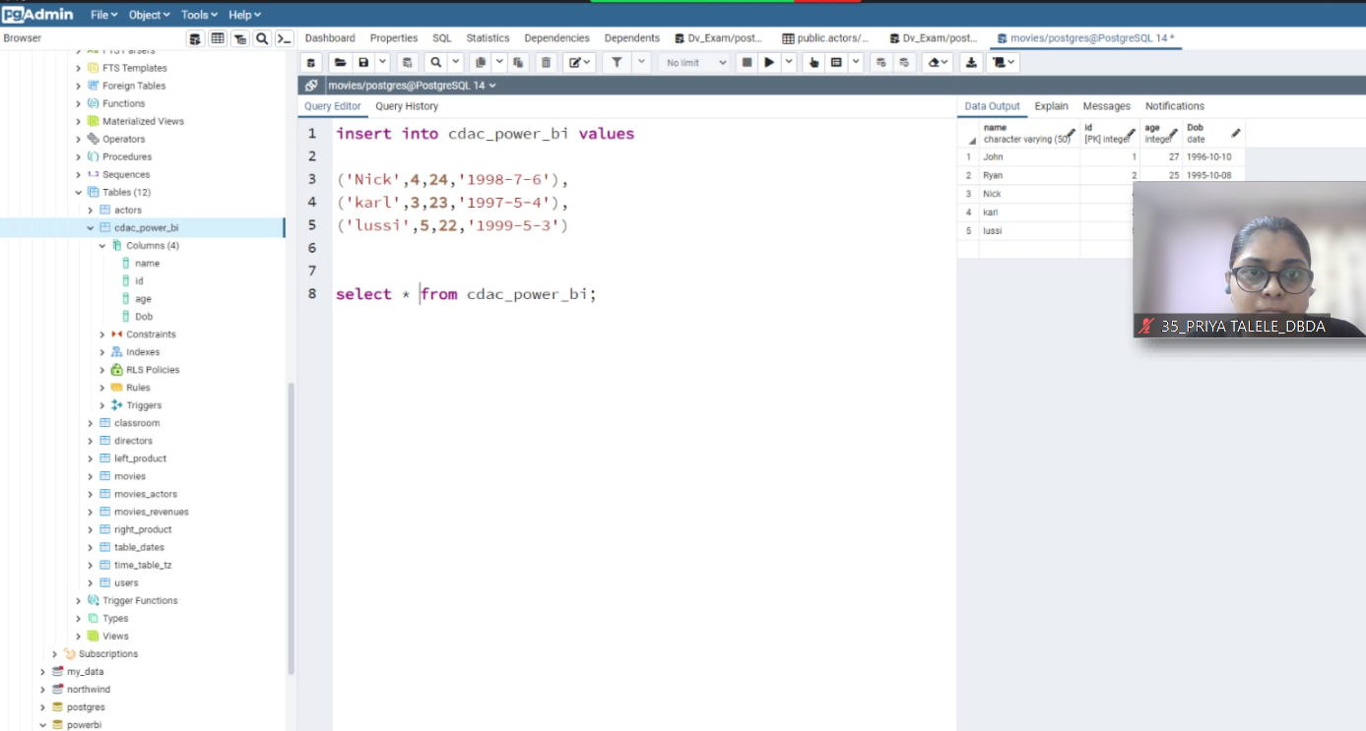

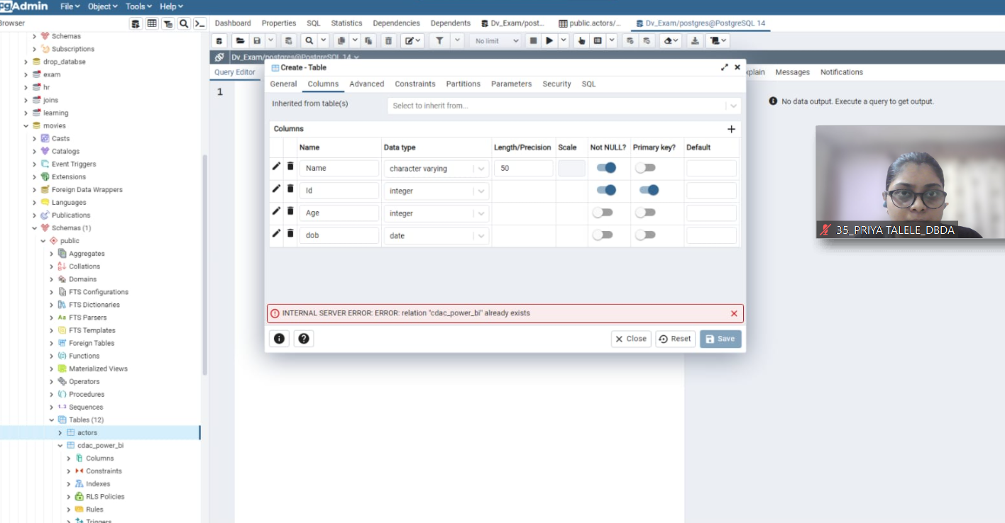

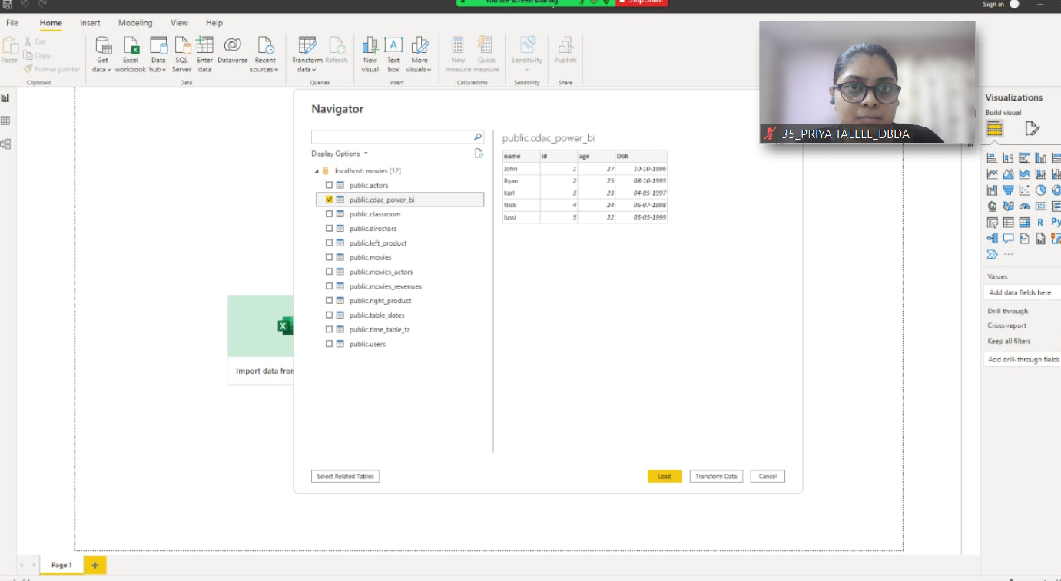

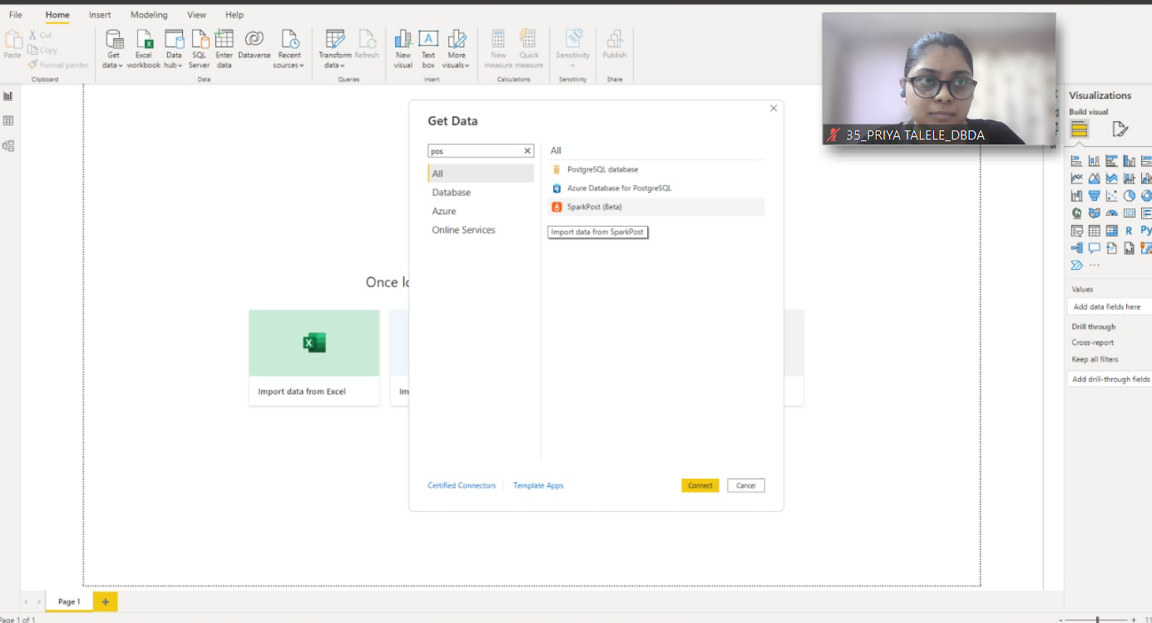

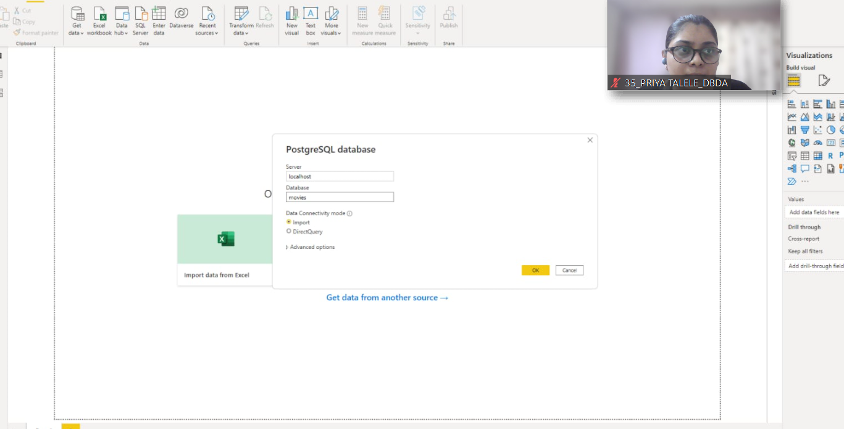

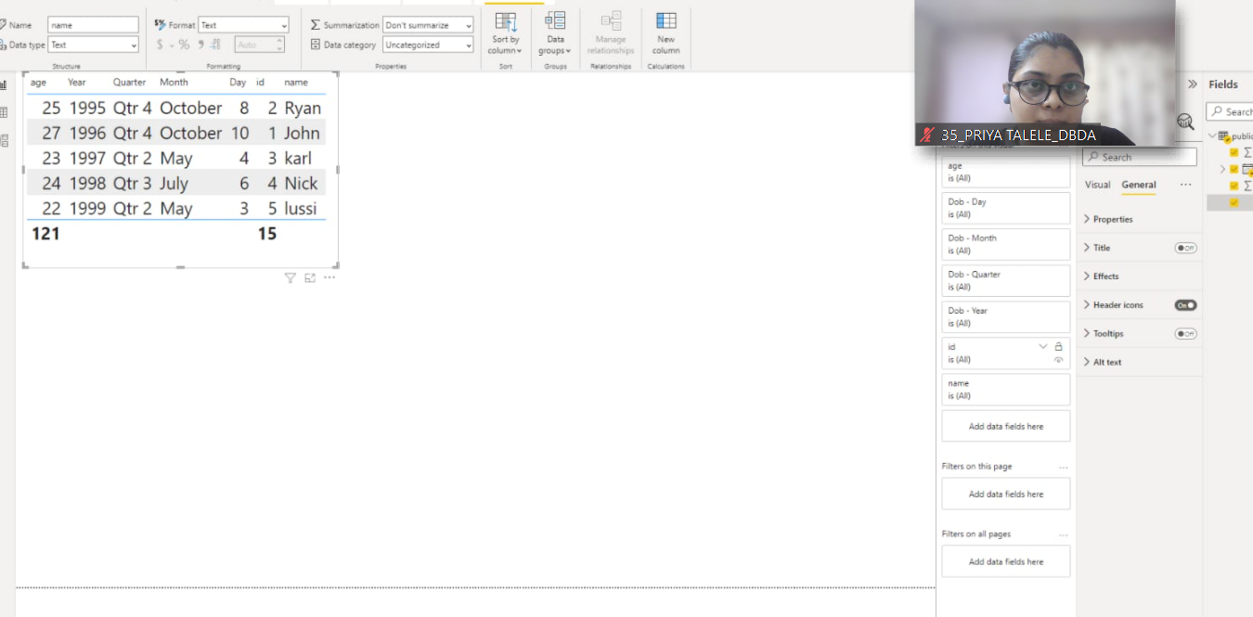

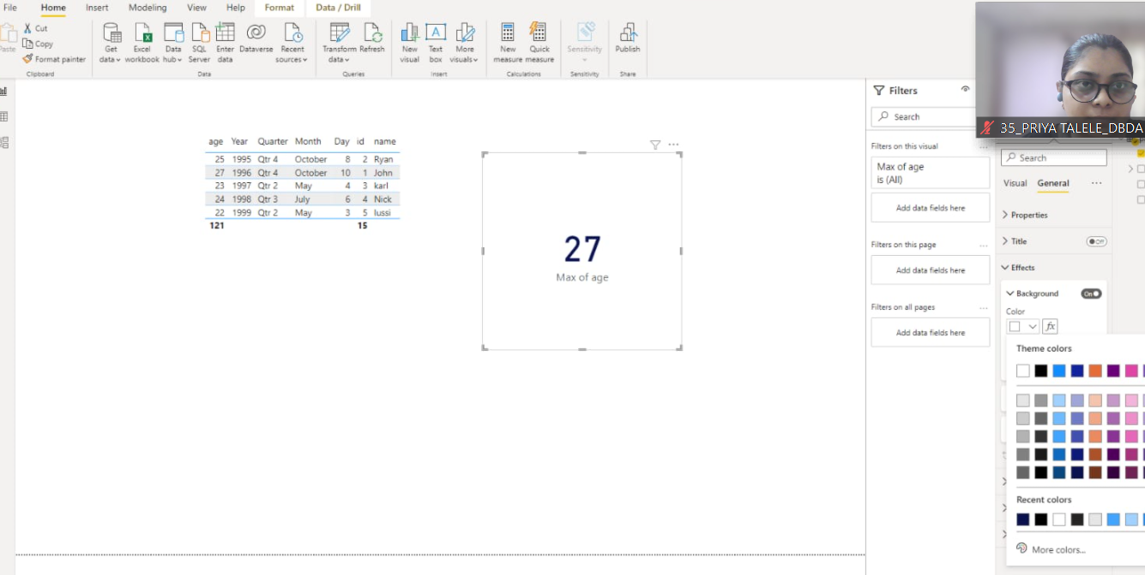

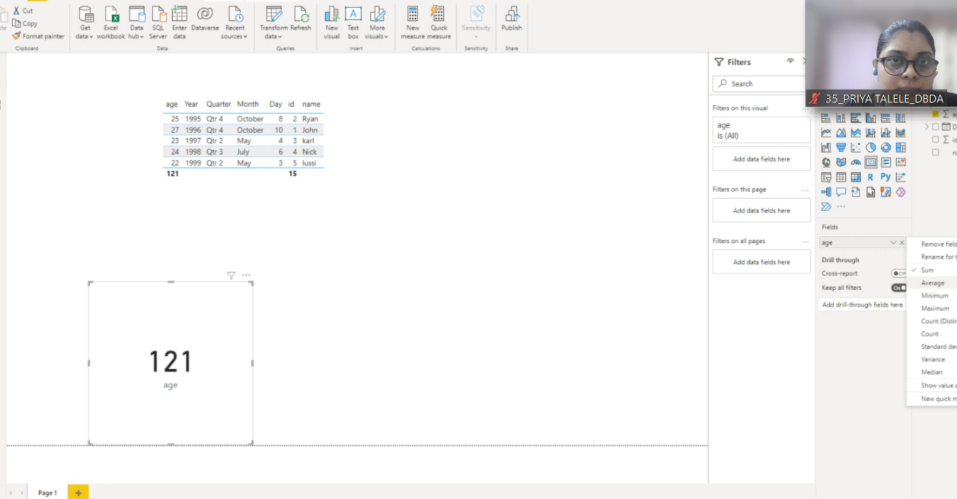

Q2.On product_table data set do the following (25 Marks)● Create table chart with title , vendor,customer name,quantity,price,city  
● Add new calculated column naming total_sales which is derived from quantity * price  
● Add new measure naming max_price to get max of price column and then display every  
vendor max price in table chart  
● Create pie chart showing the value and percentage of quantity by vendors  
● Create one more column naming total_sales_2022 which is derived from quantity *  
price * 1.16  
● Create clustered column chart showing both total_sales and total_sales_2022● Create a slicer chart of price  
● Calculate avg sales and show in tile ● Create gauge chart with  
○ value as total_sales  
○ Maximum value as max of total_sales_2022○ Target Value as average of total_sales

